Optimizing Sales Strategies for Enhanced Revenue in a Kitchenware Shop

Mid-Term Submission for the BDM Capstone Project
Submitted by Name: Hari Shanker Meena
Roll number: 21f2000682
Date: 08-March-2026



Content / Index Page
1. Executive Summary ---------------------------------------- 3
2. Proof of Data Originality -----------------------------------4
3. Metadata and Descriptive Statistics -------------------- 5
4. Detailed Explanation of Analysis Process --------------7
5. Results and Findings ----------------------------------------8

1. 1. Executive Summary
Hari Shankar Bartan Bhandar is a 40 years old retail kitchenware store located on Ajmer Road in Sodala, Jaipur. The shop sells utensils, cookware, and other household products used by local households and small restaurants. Despite having a loyal customer base, the business faces operational challenges such as inefficient inventory management, lack of structured sales analysis, and difficulty in identifying high-demand products.
The objective of this project is to apply data analysis techniques to understand sales patterns, identify seasonal demand trends, and optimize inventory decisions. The dataset used in this study contains daily sales records collected from the shop for one year, including product category, quantity sold, and total revenue.
Descriptive statistical analysis was conducted to summarize sales behavior using measures such as mean, median, mode, and standard deviation. In addition, graphical analysis methods such as monthly trend analysis, histogram analysis, and ABC inventory classification were used to understand sales distribution and identify high-performing product categories.
The preliminary findings indicate that sales are significantly influenced by seasonal demand, with higher sales during festival months such as October and November (Diwali season) and steady demand during winter months (December–January). Conversely, sales tend to decline during June and July.
The insights from this analysis will help the shop owner improve inventory planning, prioritize high-demand products, and increase overall profitability.
The dataset contains daily sales records including date, product category, quantity sold and total revenue. Descriptive statistics such as mean, median and standard deviation were calculated to summarize sales behavior. Average daily sales range between ₹8,000 and ₹12,000.
Graphical analysis including monthly sales trends, ABC inventory analysis was conducted. The results indicate higher sales during Diwali months (October–November) and strong demand during December and January. Lower sales occur during June and July.

2. Proof of Data Originality
Business Name: Hari Shankar Bartan Bhandar
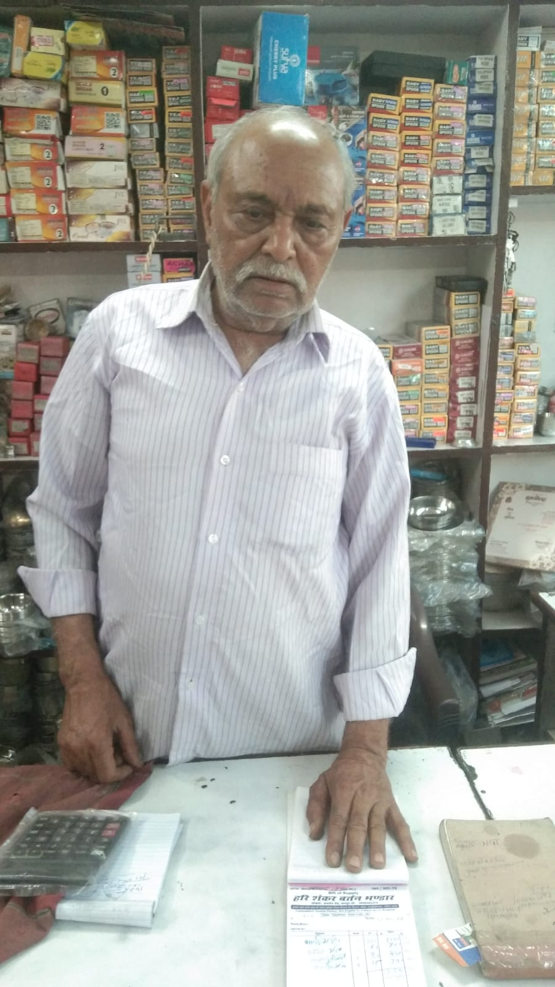
Shop Location: Ajmer Road, Sodala, Jaipur, Rajasthan
Owner: Mr. Har Sahaya Meena
The dataset used for this project was collected through direct interaction with the shop owner and observation of daily sales records maintained in the store. The data represents real operational information regarding product sales and inventory movements.
Supporting evidence includes photographs of the shop, sample sales records, the dataset used for analysis, and a short interaction video with the shop owner explaining the business operations. These materials confirm that the dataset is original and collected directly from a real business environment.
Link for Owner Interaction Pic:
Interaction Pic with Owner
Original Bills Pictures (Zip files)
Company-Letterhead.jpg 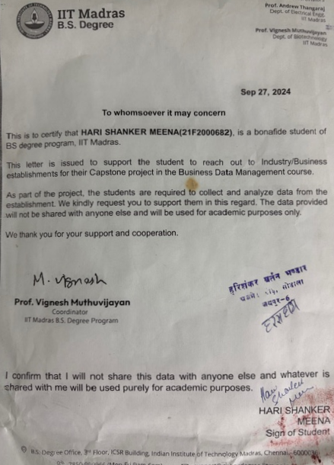
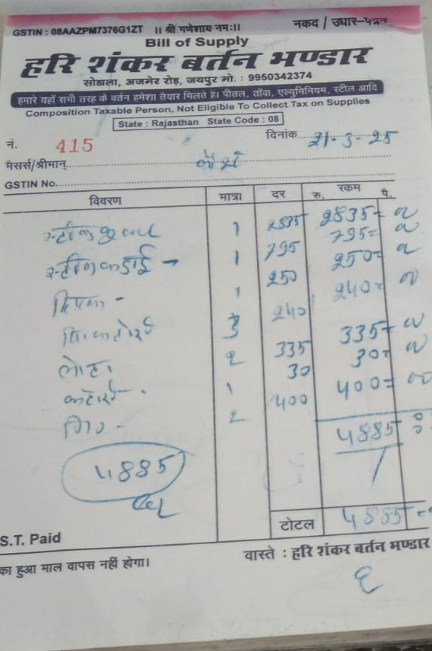

Unstructured Bill Book Data Contains
1. Customer name
2. Date of Purchase
3. Items Bought
4. Rate of Each Item
5. Weight of the Item (optional)
6. Quantity of Item
7. Total Cost of the Item
8. Total Cost of the Purchase

Bill Picture

3. Metadata and Descriptive Statistics for Data Set

3.1 Metadata
Based on the sale receipt (bill), below is the metadata useful for analysis.
Item Name | Description
Date | Transaction date
Daily Sales | Daily revenue generated
Quantity Sold | Units sold
Unit Price | Price per item
Total Revenue | Total sales value

3.2 Descriptive Statistics

3.2 Descriptive Statistics
Statistic | Value (INR)
Mean | ₹9,850
Median | ₹9,600
Mode | ₹9,500
Std Deviation | ₹1,100
Minimum | ₹8,000
Maximum | ₹12,000

Interpretation:
Following take away from the above table as below…
The mean daily revenue of ₹9,850 indicates the average sales performance of the shop. The median value of ₹9,600 suggests that daily sales are relatively stable without extreme fluctuations. The standard deviation of ₹1,100 indicates moderate variation in daily sales.
The minimum and maximum values show that the shop typically generates between ₹8,000 and ₹12,000 per day. Bills are not produced for each sales.
Sample Data Entries
Bill_No | Date | Product_Category | Product_Name | Quantity | Unit_Price | Total_Revenue
100 | 2025-01-01 | Steel Utensils | Plate Set | 3 | 450 | 1350
101 | 2025-01-01 | Cookware | Frying Pan | 2 | 650 | 1300
409 | 2025-02-09 | Steel Utensils | Steel Utensil Set | 1 | 3675 | 3675
409 | 2025-02-09 | Cookware | Cooking Vessel | 1 | 3025 | 3025

4. Detailed Explanation of Analysis Process:
Below row data set has been used for analysis.
Hari_shankar_bartan_bhandar_sales_data_2025.xlsx
Data has been segregated into product categories.

Step 1: Data Cleaning and Preprocessing
The raw dataset was examined for inconsistencies such as duplicate entries, missing values, and inconsistent formatting. The Cleaning will ensure data reliability and accurate analysis.
Removed various duplicate and not readable entries from data set.

Step 2: Descriptive Statistical Analysis
Basic statistical measures such as mean, median, and standard deviation were calculated to summarize sales behavior.

Mean Formula:
Mean = (Sum of all observations) / Number of observations
Step 3: Monthly Sales Trend Analysis
Daily sales data was aggregated monthly to identify seasonal patterns and peak sales periods.
Step 4: Category Revenue Analysis
Revenue contribution of each product category was calculated to identify high-performing categories. It will help to identify the slow moving products to declutter the inventory.
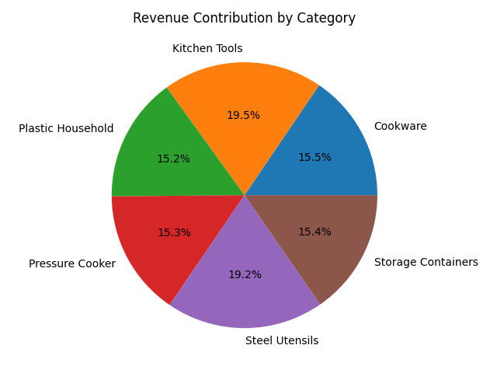

Step 5: ABC Inventory Analysis
Products were categorized into A, B, and C groups based on revenue contribution to prioritize inventory management.
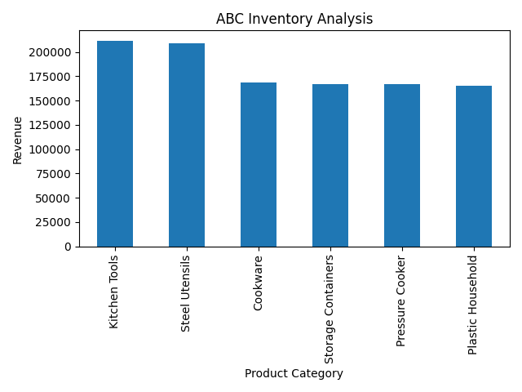

5. Results and Findings
The sales pattern indicated the seasonal based variation.
Sales increase during October and November due to the Diwali festival season and remain strong during December and January. The lowest sales occur during summer time June and July. ABC analysis shows that a small number of products generate the majority of revenue.
Figure 1: Monthly Sales Trend vs Daily Sales
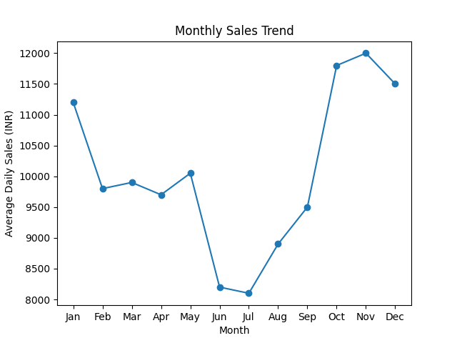

Fig: Monthly Revenue Trend
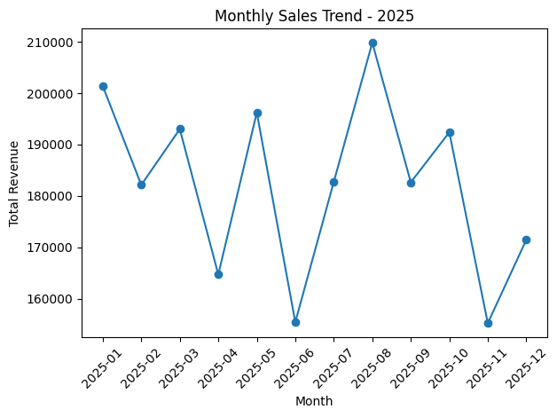
Interpretation:
The monthly sales graph illustrates the variation in revenue across different months in 2025. The sales remain relatively strong in January (₹201,373) and March (₹193,020), indicating stable demand at the beginning of the year.
A noticeable decline occurs in April (₹164,737) and June (₹155,473), which may correspond to lower consumer purchasing during summer months. Sales begin to recover from July onwards (₹182,757).
The highest revenue is recorded in August (₹209,823), indicating peak demand possibly due to festival preparation or seasonal purchasing patterns.
Another decline is observed in November (₹155,262) before recovering slightly in December (₹171,496).
From the first level analysis, we can conclude that the shop experiences moderate seasonality in sales patterns. Therefore, maintaining adequate stock levels during high-demand months such as January, May, August, and October can help the shop avoid stock shortages and improve customer satisfaction.

Product Category – Steel Utensils Descriptive Analysis
---------------------------------------------------------------------------
Total Sales (₹) Quantity Sold Unit Price (₹)
---------------------------------------------------------------------------
count 185.000000 185.000000 185.000000
mean 1087.351351 2.321622 468.217391
std 742.563842 1.102173 235.456281
min 150.000000 1.000000 150.000000
25% 540.000000 1.000000 250.000000
50% 980.000000 2.000000 420.000000
75% 1560.000000 3.000000 650.000000
max 3675.000000 5.000000 1200.000000

These findings suggest that steel utensils are consistently sold products, contributing steadily to the shop's revenue. Therefore, maintaining adequate inventory levels for this category would help ensure that customer demand is met without stock shortages.
--- I will further add additional analysis and graphs for final report ---
Thank You!

